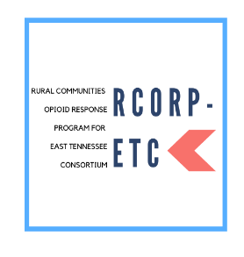
Rural Community Opioid Response Program-East Tennessee Consortium (RCORP-ETC) Meeting Evaluation
January 21, 2022

Winter RCORP-ETC Meeting
On January 21, 2022, Project HOPE (Healing Opioid Use Disorder Through Prevention and Expertise) and NOW (Nurturing Options for Women) hosted an online event for professionals who serve the RCORP-ETC 10-county area. The 2-hour event, “Rural kinship care in the opioid crisis”, included presentations by Heath Cook and April Snell of the University of Tennessee, Knoxville (UTK) and two panel discussion sessions on rural kinship care lived experience and recommendations, and community supports and gaps. Brittany Rosette-Jones and Mitchell Olszewski shared their lived experience. Tracy Van de Vate from Tennessee Office on Aging, Aisha Abu-Asaba and Carran Broadnax from Tennessee Department of Children’s services introduced kinship care services and programs in Tennessee.

Attendees
The RCORP-ETC region includes 10 counties in East Tennessee: Roane, Morgan, Union, Grainger, Hamblen, Scott, Claiborne, Cocke, Jefferson, and Campbell (see Figure 1). The consortium is co-led by UTK and has more than 150 members. The meeting flyer was posted on the project website, social media, and sent out through UTK Tennessee Today. Invitations for the RCORP-ETC Consortium Meeting were emailed to all consortium members, who were also invited to share the invitation with interested colleagues and community members. Ninety-three people registered for the training and 50 professionals attended. Of the registrants, 30.5% heard about the event through the consortium listserv, 24.8% were recommended by their employers, and 21.9% were recommended by a friend or colleague. Some found the event through the project website (10.5%) and social media (3.8%).

Evaluation
Of the 50 attendees, 14 (28%) completed the evaluation survey. Attendees included legal professionals, social workers, non-profit professionals, community-based nurses, certified peer-recovery specialists, public health professionals, students and faith-based community members. The attending professionals work in or serve 15 counties: Campbell, Claiborne, Cocke, Grainger, Hamblen, Jefferson, Morgan, Roane, Scott, Union, Knox, Blount, Sevier, Hamilton, and Williamson.

Figure1.
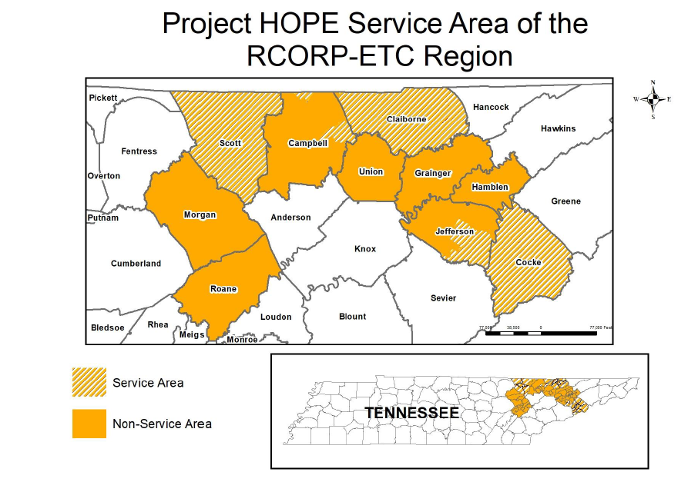

Evaluation of Training
The overall experience of the meeting was well regarded by attendees, as all participants shared they would recommend the meeting to a colleague.

Attendees indicated how satisfied they were with the meeting, possible answers ranged from very dissatisfied (1) to very satisfied (5). On average, participants’ answers ranged between satisfied (4) and very satisfied (5) on every question. Attendees were very satisfied with the knowledge of the presenters (4.93), training content (4.79), relevance of the training to their needs (4.79), and engagement of the training (4.71).

Attendees retrospectively indicated how much they knew before and after the training session for a series of learning objectives. Possible answers ranged from nothing at all (1) to a whole lot (4). On average, attendees reported knowing between little bit to a lot before the training (grand mean= 2.26) and between a lot to a whole lot after the training (grand mean=3.55, p<0.001). Significant increases in knowledge emerged for most learning objectives (Table 1). The largest increases were in knowing current kinship care related services, policies and culture (p<0.001), knowing stigma and services for kinship families (p<0.001), and clarifying the status of kinship care and meaning for young people and families (p<0.001).

Attendees rated how effective each program component was in gaining a deeper understanding of the importance of kinship care in rural communities. Possible answers ranged from not at all effective (1) to extremely effective (5). On average, attendees’ answers ranged from moderately effective to extremely effective on every question. Attendees reported that the two panel discussions were extremely effective in developing a deeper understanding of the important of kinship care in rural communities (mean 4.57 and 4.50).

Table 1.
Learning Objectives | Pre-Score | Post-Score | Mean Difference | p-value
The status of kinship care and meaning for young people and families | 2.36 | 3.57 | 1.21 | <0.001
Stigma and services for kinship families | 2.29 | 3.57 | 1.28 | <0.001
Current kinship care related services, policies and culture | 2.14 | 3.50 | 1.36 | <0.001

Suggestions from Attendees
Attendees were asked to provide insight on how future meetings may be improved. Most attendees had no recommendations. Of the few responses, some preferred more emphasis on gaps and potential solutions, more presenters and longer training, and more time for speakers to share their experiences.

