**EXTRA, EXTRA, READ ALL ABOUT IT!**

RESOURCE INFORMATION

CARREN Pirtle -Broadnax, RESOURCE LINKAGE

**April 2022**

**Schools Out For Summer**

MCED00003_0000[1]Knox County Schools last day is May 25, 2022, which will be a half day. There are several types of summer program available for children.

**Boy & Girls Clubs of the Tennessee Valley**: Accepts children from ages 5 to 17 years old in their program. They have several locations available. Summer program from 7:30am until 6pm. Check them out @ [www.bgctnv.org](http://www.bgctnv.org) . Cost - $50.00 a week /voucher are also accepted.

|  |
| --- |
| **The City of Knoxville Parks and Recreation Department hosts it’s Summer Playground Program**, open to Knoxville residents, at each of its 12 recreation centers located in all sections of Knoxville. This program provides a wide variety of recreational activities, including swimming, canoeing and field trips to the Knoxville Arts and Fine Crafts Center. Participants are provided lunch each day at certain locations. For more information, call 865-215-1414. |
| |  |  | | --- | --- | | **Ages:** | **6-12 years of age** (Must be 6 years old by 6/1/2022) | | **Dates:** | **June 6 - July 29 NO CAMP - July 4-8 (week of July 4th)** | | **Days/Times:** | **Monday thru Friday 8 a.m. to 4 pm.** | | **Costs:** | **City Resident Registration Fee - $20 Non-City Resident Fee - $50 Weekly Fee - $20 per week (due week before)** | | **Summary:** | **\* Lunch & Snack Provided Daily \* Field Trips \* No additional fees** | | **How to Register:** | **Call rec center to register beginning Monday, April 4, 2022.  Space is limited.** | |

**Wesley House STEP**

Our Summer Time Enrichment Program (STEP) is designed to help families during the summer when school is out of session. Because we understand the need for kids to have a safe and secure environment while mom and dad are at work, we have a daily program that runs from 7:30 a.m. - 5:30 p.m. for nine weeks starting June 1st to July 29th, 2022. We provide breakfast, lunch and a snack daily, along with enrichment activities, spiritual support, and educational field trips. Total cost for summer is $385.00 (or 43.00 a week). 10% discount available for siblings and some limited scholarships available too.

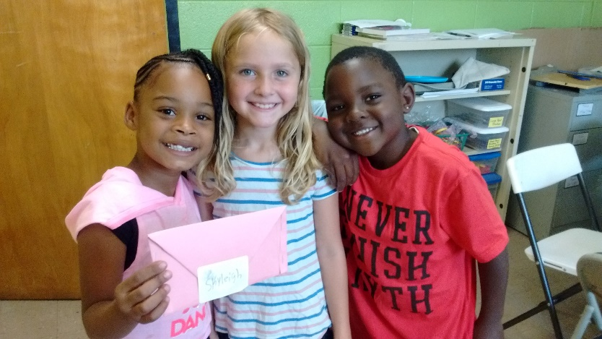**YWCA - Phyllis-Wheatley-Center**

Summer Kids in Play Program **(SKIPP)** is a popular summer option for families needing a safe place for their children during the summer break. This 8 week-long summer day camp offers enriching programming for children, ages 5 to 14. Students enjoy the summer reading challenge, intensive swim lessons, working in the garden, and cooking classes. Students also enjoy weekly field trips to local attractions such as Ijams Nature Center, Muse Knoxville, Great Smoky Mountains National Park, and Zoo Knoxville.

SKIPP focuses on keeping costs low for busy parents, cultivating a love of reading, and leading social and cultural development. Scholarships are available. Spots fill up fast, so families are encouraged to register early.

(Total cost: Enrollment $50.00; $150 for 8 weeks)

SKIPP Registration is open.

Here is the link to online registration form.

[https://form.jotform.com/210798249376166](https://urldefense.com/v3/__https:/form.jotform.com/210798249376166__;!!PRtDf9A!9yKphAX6qSnesd9w7ww6IAm6UL6AAsefQu8csWz96iYwqS6JWaGvrtbQhLj8Ign5vao7$)

• Contact at info@ywcaknox.com or 546-0651 for additional more information.

**East TN Freedom Schools -** [ABOUT | easttnfreedomschools](https://www.easttnfreedomschools.com/about1-c1x1t)

The Children’s Defense Fund’s (CDF) Freedom Schools® program is a six-week long summer enrichment program with 3 hours of reading per day. (June 13 – July 22nd, 2022) from 8am to 3pm. The program helps children fall in love with reading, increases their self-esteem, cultivates positive attitudes toward learning, and reduces summer reading loss—one of the major challenges affecting poor and working-class children. Attending our school is **FREE** for all families and children 5-18 are eligible. Sites this year: Sarah Moore Greene Elementary, Green Elementary, Blount County and main Boys & Girls Club site.

**Knox County Schools Free Summer Learning Camps -**[knoxschools.org/summerlearning](https://urldefense.com/v3/__http:/track.spe.schoolmessenger.com/f/a/Cs-p0FwHV0iZq8vmQd5D7A**A/AAAAAQA*/RgRkH2GBP0QpaHR0cDovL3d3dy5rbm94c2Nob29scy5vcmcvc3VtbWVybGVhcm5pbmdXB3NjaG9vbG1CCmI9AS4-YuHNGchSHGZhdm9yYWludGZhaXIuMS5jYkBnbWFpbC5jb21YBAAAAAE*__;fn5-fg!!PRtDf9A!_iR5YC5oG-aeSOpmbwGP3rjU5X52gbnlIkFh3qgLfYgKCMgIOBTLRGA7JwgWGFd3yLGD$)

Knox County Schools will be hosting free summer learning camps this summer four weeks each.

***Elementary:***

For eligible students who are entering Grades 1-5 in the fall, Knox County Schools will be offering a 4-week Summer Learning Program that will begin on May 31 and will run through June 24. This camp will include 7 hours of daily, in-person programming from 7:45 a.m. to 2:45 p.m. Monday-Friday, including:

* 4 hours of reading, writing, and math instruction.
* 1 hour of intervention.
* 1 hour of play; and
* 1 hour of S.T.R.E.A.M. instruction.

**“S.T.R.E.A.M.” programming will focus on Science, Technology, Reading, Engineering, Arts and Math.**

**Additional Benefits**

The Summer Learning Program will be provided at no cost to families, and will include the following:

* Bus transportation.
* Free breakfast and lunch meals.
* Pre- and post-camp testing to measure student progress.

***Middle School***:

For eligible students who are entering Grades 6-8 in the fall, Knox County Schools will be offering a 4-week Learning Loss Summer Bridge Camp that will begin on ***June 1 and will run through June 28***. This camp will include ***6 hours of daily, in-person programming from 8 a.m. to 2 p.m. Monday-Friday***, including:

* 4 hours of reading and math instruction
* 1 hour of intervention
* 1 hour of physical activity

**Additional Benefits**

The Summer Bridge Camp will be provided at no cost to families, and will include the following:

* Bus transportation
* Free breakfast and lunch meals
* Pre- and post-camp testing to measure student progress

**Knoxville MOMS Blog**:

<http://knoxville.citymomsblog.com/guide-to-knoxville/summer-camps/>

**IJAMS NATURE CENTER**

<http://ijams.org/programs/camps/>